Allan Gray

# May 31, 2022

### Business Requirements

1. Requirements for the Allan Gray assessment are as follows:
   1. Read the included tweets.txt file.
   2. Read the included user.txt file.
   3. Output the results in the form of a twitter feed.

### Target Audience

Allan Gray hiring manager

### Technical Specs

1. Language: C#
2. Framework: .net Core 5.0
3. Unit test: xUnit
4. IDE: Visual Studio 2019

Solution

### Project 1. GA.Cli

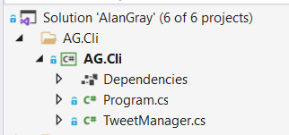

Fig. 1 - CE.Api / CE.Cli

This project consists of the Main.cs file and theTweetManager.

The TweetManager class contains the Run method which is invoked by the Main.cs class. The Run method contains the high-level logic to read and build a user and tweet list. The display of the results is executed by the Run method, but the logic is separated into different services and classes. This should make testing easier.

### Project 2. GA.Data

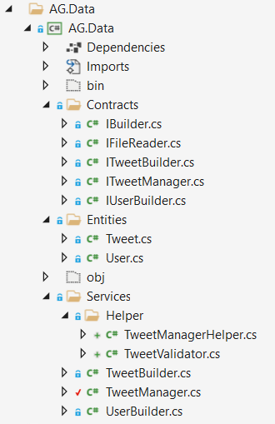

Fig 2. AG.Data

The AG.Data project contains five contracts. These interfaces define the functionality of the services declared in the Services folder. The IBuilder defines the Build function which is inherited by the ITweetBuilder and IUserBuilder interfaces. Additional specialized functions can be defined in ITweetBuilder and IUserBuilder.

1. IUserBuilder is implemented as a service to perform the reading of the user.txt file. The actual reading is delegated to the IFileReader which is injected into the UserBuilder service during runtime. This separates the file reading logic into its own class and can easily be swopped out for another implementation.
2. IProdService is implemented as a service to query and update products.
3. ILoggerService is used to implement the NLog logger package.

These interfaces are injected through dependency injection and makes it easier to perform testing. Implementation can be easily swopped out just by defining another concrete implementation in the DI container.

### Project 4 - CE.IoC

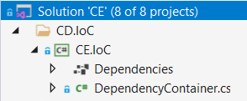

Fig 3. CE.IoC

The Di project registers all the interfaces for dependency injection. This function is normally done inside the Startup.cs class but externalizing this into a separate project, it keeps the Startup.cs cleaner.

### Project 5 - CE.Services

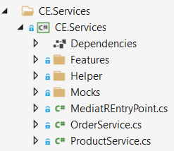

Fig 4. CE.Service

The service project is used to separate the different functions into separate logical components. The service classes implement the corresponding interfaces in CE.Contracts project which is then injected into the controllers.

### Project 6 - CE.Test

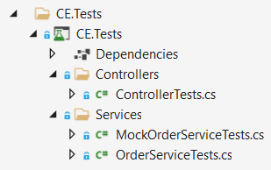

Fig 5. CE.Test

The last project is an Xunit test project for running unit tests. The application is developed using a TDD approach.

CE.UI

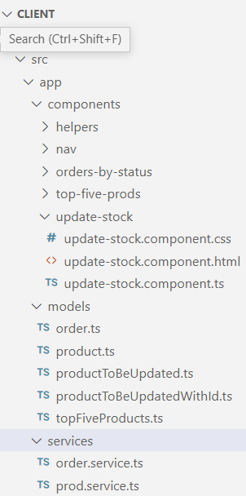

Fig 6. Angular client project

As mentioned, the frontend is done in Angular 12. No specific version 12 commands were used so this should work in earlier versions of angular.

The Fig 6 shows the logical structure of the frontend –

1. Components: This houses the different components used in the project.
2. Services: there are two services in the Services folder that communicates with the CE.Api project by sending data in the form of parameters.
3. Models: contains the entities used in the project.

### List of IN PROGRESS orders

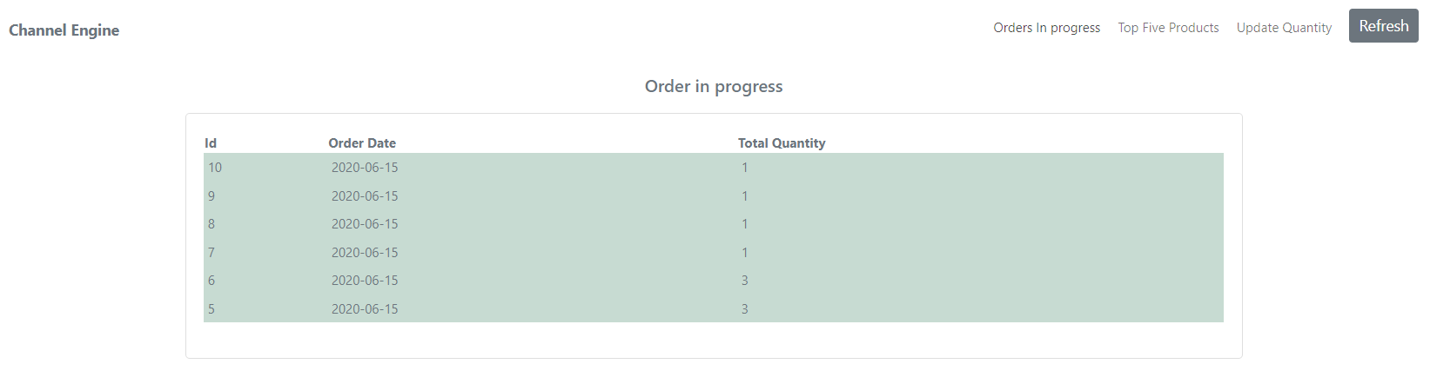

Fig 7. Orders in Progress

Fig 7 shows the list of in progress orders. Clicking on the ‘Orders In Progress’ hyperlink near the top left corner, a call to the orders service is made. This service will in turn contact the backend service which will make an api call to the public endpoint. Data is then passed all the way to the client device where it is displayed. Communication is asynchronous.

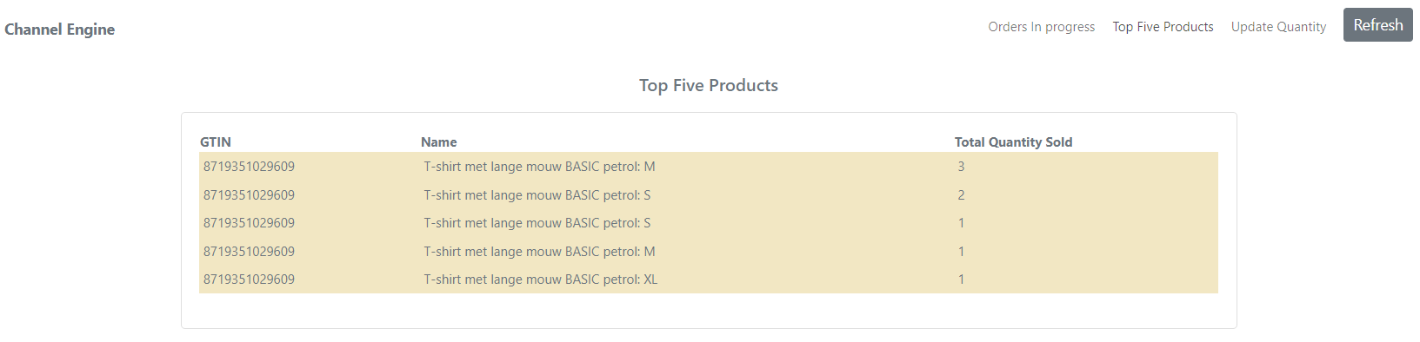

Fig 8. Top Five products

By clicking on the Top Five Products link, the same communication pattern is followed as in Fig 9 to display a list of the top five products being sold.

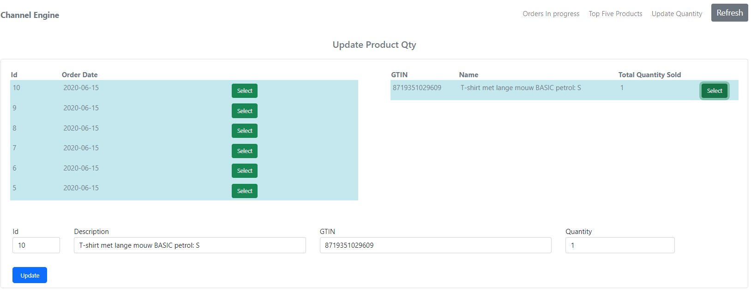

Fig 9.

Fig 11 displays the stock update function. Click on the Update quantity. The list to the left is displayed. By clicking on any of the ‘Select’ buttons – the product detail is displayed in the detail table. Finally clicking on the right line will populate the text boxes. Change the quantity field and click on the ‘Update’ button. This will make post request to the backend server to update the right stock count.

Using Angular allows for dependency injection on the client side as well as an mvc dependency design patter to logically divide the logic into separate modules. The use if services allow for the reuse of components.

Console Output

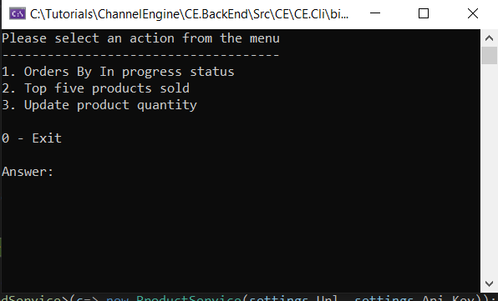

Fig 10. Application menu

Orders in progress

## 

Fig 11. Orders in progress

Fig 11 shows the output of all the orders with a status of IN_PROGRESS. In the console application, I used the injected IOrderService interface to show the use of a different pattern. The logic is still reused from the Api implementation.

Two new classes (DisplayFormattedData.cs and DisplayFormattedProductData.cs) are added to abstract the display logic away from the Runtime class.

Top five Products

## 

Fig 12. Top Five products

Orders Listing activity diagram

Fig 13. Get orders activity diagram

## Conclusion

The construction of the solution is hopefully done in a way that supports loose coupling and high cohesion.

1. Class, method and variable names are given meaningful values. The only time where x is used as variable is as a loop counter variable.
2. The controllers do not contain any logic. Filters can be used to remove redundant code such as try catch.
3. Fields are declared with a leading _ to indicate the role it plays and can be found at the top of each class.
4. Any injected dependency (services) is declared as read-only to keep it immutable.
5. Dividing the solution into separate projects, make the application more testable and maintainable.
6. Please note that all requests are handled asynchronously.
7. The solution is based on TDD.

To get the solution running:

1. Start the api solution. The default url is <http://localhost:5000> and <https://localhost:5001> for https.
2. After opening the angular solution – run the npm install command. This will install all the dependencies needed.
3. Run the front end with ng serve. The default url is <http://localhost:4200>.
4. Testing can also be performed with the use of swagger. Go to url <https://localhost:5001/swagger/index.html>
5. Alternatively – import the the swagger.json (included) into postman. This will setup all the existing endpoints in postman.